ICRS Competency Framework: Guiding Principles, Core Competencies and example evidence

Contents
ICRS Competency Framework: Guiding Principles and Core Competencies 2
ICRS Competency Framework Diagram 3
Guiding Principles and example evidence 4
Core Competencies and example evidence 13

ICRS Competency Framework: Guiding Principles and Core Competencies

This section contains information on the ICRS Competency Framework.
The ICRS Competency Framework includes two elements:
- Guiding Principles, which are informed by, and shape an understanding of, the CR and sustainability agenda. The four Guiding Principles are the building blocks of the CRS profession, and the lenses through which practitioners view their role and the impact of the organisations in which they work. Each Guiding Principle is divided into six themes:
  - Awareness
  - Advocacy and advice
  - Compliance
  - Strategy
  - Stakeholders
  - Communication

- Core Competencies of a CRS professional. There are five Core Competencies. Practitioners will be expected to draw on the five Core Competencies to demonstrate each of the Guiding Principles.
The elements are inter-related and together are more than the sum of their parts. This relationship is demonstrated in the diagram on page 3.

ICRS Competency Framework Diagram

This diagram shows how the four Guiding Principles in the center are inter-related to the Core Competence on the periphery of the circle.
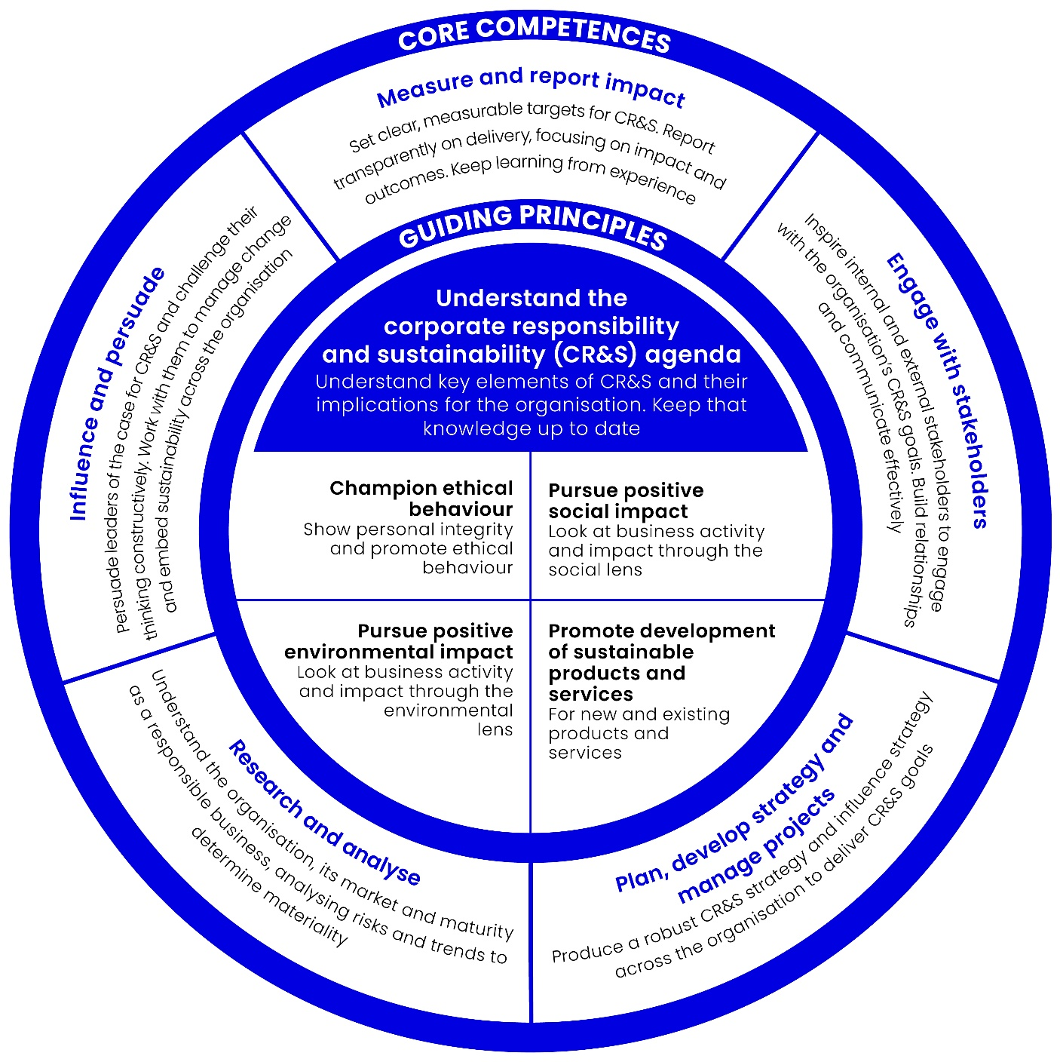

Guiding Principles and example evidence
The following tables provide a summary of the Guiding Principles of the ICRS Competency Framework, along with example evidence from previous successful applicants.

Guiding Principles
Theme | Champion Ethical Behaviour | Pursue Positive Social Impact | Pursue Positive Environmental Impact | Promote Development of Sustainable Products and Services
Awareness | - Understand the main ethical and good corporate governance issues faced by an organisation and, if relevant, its supply chain, and what it’s policy should be in relation to those issues.  - Horizon scan for issues that an organisation may face in the future and determine policies in relation to those.  - Keep informed of the latest debate and thinking on ethical issues, and the role of business in relation to ethics. | - Understand the main social issues, including wellbeing, inclusion and diversity, labour and human rights, and their relevance to the organisation, domestically and internationally.  - Identify the main social risks faced by an organisation and what an organisation’s strategy should be in relation to those risks.  - Identify an organisation’s principal social impacts through the entire value chain, through a systematic approach entailing both qualitative and quantitative assessments, where appropriate.  - Keep informed regarding, and where appropriate contribute to, the latest debate and thinking on social issues, and the role of business in society.  - Understand the statutory and legal requirements around how business operates in society, and ensure compliance | - Understand the main local and global environmental issues, including climate change, pollution, water scarcity, unsustainable consumption and waste, and their relevance to an organisation.  - Identify the main environmental risks faced by an organisation and what the organisation’s strategy should be in relation to those risks.  - Identify an organisation’s environmental impacts through the entire value chain, and how an organisation can achieve cost savings by addressing environmental impacts and market differentiation by developing environmentally sensitive products or services.  - Know when to consult experts for technical expertise on environmental management.  - Keep informed regarding, and where appropriate, contribute to, the latest debate and thinking on environmental issues, and the role of business generally in relation to the environment.  - Understand the statutory and legal requirements around the environment and ensure compliance. | - Understand the principal social, environmental and economic impacts of an organisation’s products and services throughout their life cycle.  - Understand how an organisation improves its existing product and service offerings and develops its portfolio.  - Keep informed of how competitors and other organisations are developing their products and services to minimise or eliminate negative sustainability impacts and promote positive impacts.  - Keep informed of how technological, regulatory and other developments may provide opportunities for improvements in the sustainability of products and services.

Guiding Principles
Theme | Champion Ethical Behaviour | Pursue Positive Social Impact | Pursue Positive Environmental Impact | Promote Development of Sustainable Products and Services
Awareness | Example:  Many of my consulting projects require a finely developed sense of the wider environment concerning ethical expectations on business and how this is developing.  Practical examples are the work I have done with [Company Name] to identify the ethical issues facing their supply chain (including bribery, corruption, transparency, animal welfare, labour rights etc.) and to frame a global programme in response. A simple publicly- available example is found in [Report Name] which I wrote for the media sector.  (Consultant)  INSERT YOUR OWN EXAMPLES HERE | Example:  Having worked in CR for the last 8 years and led on CR strategy development and project planning I am experienced in materiality analysis and stakeholder engagement aimed at pinpointing relevant social risks, issues and opportunities to underpin an impactful CRS approach. I recognise the importance of addressing ‘what matters’ and ensuring interventions are targeted, and their effectiveness measurable.  (In-house) | Example:  Most consulting assignments start with the need to understand the environmental issues facing a corporation, the risks and opportunities, and then frame a compelling and actionable response. I have completed many formal environmental reviews ranging from ISO14001 initial assessments to much more strategic ones. Examples are initial environmental Reviews for [Company Name] [Company Name]. At the most strategic end, I worked with [Company Name] to develop a best in-class response to a wide range of environmental topics. (Consultant) | Example:  Over the last four or five years an increasing amount of my work has focused on the social and environmental impacts of companies’ core business models and their products and services. Recently I worked with [Company name] to explore how upstream design decisions and purchasing practices affected the ability of factories to meet social goals. (Consultant)

Guiding Principles
Theme | Champion Ethical Behaviour | Pursue Positive Social Impact | Pursue Positive Environmental Impact | Promote Development of Sustainable Products and Services
Advocacy and Advice | - Encourage an environment of professionalism, openness, transparency, mutual respect and support.  - Develop compelling arguments for addressing ethical and good governance issues. | - Encourage concern for an organisation’s societal impacts both within the organisation and with key stakeholders outside the organisation.  - Develop a compelling narrative that promotes internal understanding of the organisation’s social impacts and the role of business in society. Share this narrative with key external stakeholders.  - Encourage senior management to proactively address any negative social impacts of an organisation and its suppliers and embrace the positive role that an organisation can play within society.  - Provide coherent, accurate, and objective advice on social issues and persuade other of its applicability to the business. | - Encourage concern for the environment within an organisation and with key stakeholders outside the organisation.  - Develop a compelling narrative that promotes internal understanding of an organisation’s environmental impacts and the role of business in the environment. Share this narrative with key external stakeholders.  - Advocate opportunities for reducing negative environmental impact and enhancing positive environmental impact.  - Encourage senior management to take a strong stance on environmental issues.  - Provide coherent, accurate, and objective advice on environmental issues and persuade other of its applicability to the business. | - Provide compelling arguments in favour of incorporating changes to existing products and services that will reduce negative social, environmental and economic impacts and/or promote positive impacts.  - Provide compelling arguments in favour of developing new products and services that minimise or eliminate negative social, environmental and economic impacts and/or deliver positive impacts.  - Raise awareness of the importance of improving the sustainability of products and services with senior management and encourage them to act as advocates for the benefits.

Guiding Principles
Theme | Champion Ethical Behaviour | Pursue Positive Social Impact | Pursue Positive Environmental Impact | Promote Development of Sustainable Products and Services
Advocacy and Advice | Example:  As a strategy consultant, I often have to advocate a particular course of action. Recently, for an FMCG client I did a benchmarking exercise of the client’s current ethical practices compared with their peer group.  I identified examples of leading edge practice and instances of poor practice, which I, with a senior colleague, presented to the Heads of Corporate Affairs, Legal, HR and Operations. We convinced the company that they needed to develop a programme of training for around 500 employees – including buyers, factory and other functional managers.  (Consultant)  INSERT YOUR OWN EXAMPLES HERE | Example:  I regularly contribute to the company’s input to government consultations e.g. most recently the Open Consultation on CR, and apprenticeship funding.  (In-house) | Example:  I regularly help clients make the case for change, and prepare board presentations to sell the idea to their senior colleagues. One concrete example is [Company name], where I helped convince the Board that a major overhaul of their responsible procurement strategy was necessary  (Consultant) | Example:  I regularly support client teams in development of sustainability services propositions, either as part of our specialist sustainability consulting practice, or as part of the general mainstreaming of environmental and broader sustainability requirements on ‘ standard’ consulting or outsourcing projects.  I also regularly participate in meetings with senior government stakeholders to inform government’s approach to CR, contribute to government programmes aimed at involving / enhancing private sector investment in the UK and wider communities, as well as help generally to highlight the role played by the private sector in contributing to the social, economic and environmental sustainability of the UK.  (Consultant)

Guiding Principles
Theme | Champion Ethical Behaviour | Pursue Positive Social Impact | Pursue Positive Environmental Impact | Promote Development of Sustainable Products and Services
Compliance | - Follow and uphold relevant organisational or industry-specific codes of conduct. | - Comply with, maintain, support or develop (as appropriate) effective policies and procedures concerning human rights, ethical sourcing, bribery and corruption and community impact. | - Comply with, maintain, support or develop (as appropriate) effective policies and procedures concerning greenhouse gas emissions, pollution, water scarcity, unsustainable consumption and waste.
 | Example:  Over the past 6 months I have worked with our in-house Legal and Compliance teams, to revise our company’s policy on Bribery and Corruption, so that it meets the UK Bribery Act’s requirements  (In-house) | Example:  I have carried out social impact assessments for large construction projects and written policies on community engagement. I have also helped companies meet the new UK mandatory reporting requirements on diversity. (Consultant) | Example:  I have helped companies comply with environmental legislation. One example was when I analysed the new EU Biocidal Products Regulation (which came into force in September 2013) for a large general retailer, and briefed them on what the requirements would be for their business, and how it would affect them down to the product level.  (Consultant)

Guiding Principles
Theme | Champion Ethical Behaviour | Pursue Positive Social Impact | Pursue Positive Environmental Impact | Promote Development of Sustainable Products and Services
Strategy | - Maintain, support or develop (as appropriate) effective policies and procedures concerning bribery, corruption, whistle-blowing and good corporate governance.  - As appropriate, help embed a code of ethics in an organisation and the supply chain. | - Identify opportunities for reducing negative social impact and enhancing positive social impact on the societies in which an organisation operates. Develop a compelling strategy and business case for an organisation to pursue those opportunities | - Identify opportunities for reducing negative environmental impact and enhancing positive environmental impact.  - Develop and pursue adoption of strategies for delivering a positive environmental impact. | - Identify and utilise ways to contribute to the product and service improvement or design process.
 | Example  This year I led the development of my company’s first materiality matrix for sustainability. In the past, the company reacted to sustainability issues purely based on perception and anecdote. Now we have a rigorous process, and the management team is committed to proactively responding to the issues highlighted through it.  (In-house)  INSERT YOUR OWN EXAMPLES HERE | Example:  I have devised our internal diversity and equal opportunities strategy. I am also accountable for defining and overseeing the execution of the company’s Citizenship strategy, which includes community investment.  We have a clearly articulated focus, goal and narrative which is proving compelling with clients, government stakeholders and our people. Using community investment as a platform for innovation (e.g. trying out new products and solutions) has also allowed us to develop new skills and capabilities that are proving viable in a commercial context, further cementing the business case for community investment activity.  (In-house) | Example:  I have devised a supply chain environment strategy for my company, a major UK fashion brand. I based this on an earlier materiality analysis which demonstrated the areas (the parts of the world and the processes in their supply chain) which have the greatest impact on the environment  (In-house) | Example:  Responsible growth is at the core of our UK business strategy. That means working to decouple our growth from our environmental impact and ensuring we continue to scale our positive social impact as the business grows. Each year, the Corporate Citizenship strategy contains activities to continuously identify opportunities to reduce negative impact and enhance the positive impacts of our service delivery, our operations and our people through development of new products, services or ways of doing things. As an example, I have played a key role in the development of a new business model and establishing the business case for an on onshore delivery centre in the UK employing technology apprentices to provide onshore services at near-shore prices to help keep jobs in the UK as an alternative to offshoring.  (In-house)

Guiding Principles
Theme | Champion Ethical Behaviour | Pursue Positive Social Impact | Pursue Positive Environmental Impact | Promote Development of Sustainable Products and Services
Stakeholders | - Consider the views of stakeholders, understand their main concerns and their impact on a business, and engage in constructive dialogue on ethical and good corporate governance issues.  - Identify opportunities for collaboration with external organisations on business ethics and good corporate governance.  INSERT YOUR OWN EXAMPLES HERE | - Form strong relationships with relevant stakeholders, especially in community and civil society organisations.  - Consider the views of stakeholders, understand their main concerns and their impact on a business, and engage in constructive dialogue on social issues.  - Demonstrate empathy for people and society.  - Identify opportunities for collaboration with external organisations on addressing social impacts. | - Identify, and build strong relationships, with relevant environmental stakeholders.  - Consider the views of stakeholders, understand their main concerns, and their impact on a business, and engage in constructive dialogue on environmental issues.  - Identify opportunities for collaboration with external organisations on addressing environmental impacts. | - Form strong relationships with internal and external stakeholders involved in the product and service improvement and design process and be prepared to challenge assumptions (for example, in relation to “business as usual” and/or the efficacy or otherwise of improving sustainability performance).  - Identify and utilise appropriate media for engaging with stakeholders, including customers, consumers and clients, to ascertain their views on how products and services can become more sustainable.  - Identify opportunities for collaboration with external organisations (including competitors, suppliers and other public and private sector entities) to improve the sustainability of products and services.

Guiding Principles
Theme | Champion Ethical Behaviour | Pursue Positive Social Impact | Pursue Positive Environmental Impact | Promote Development of Sustainable Products and Services
Stakeholders | Example  I have designed and organised a bribery/corruption stakeholder dialogue for a large retailer [company name]. The results of this work formed the basis for the client’s policy on B&C. I spent considerable time liaising directly with NGOs both in the UK and overseas to ensure that their views were captured in the final document.  (Consultant)  INSERT YOUR OWN EXAMPLES HERE | Example:  In my role, I manage a large number of stakeholders; internally and externally across the public, private and voluntary sector.  Internally; I report to our UK CEO and work closely with senior leaders across the business to help them to take ownership of social impact e.g. through acting as “client account leads” for our strategic community partners and providing quality assurance on pro bono consulting projects.  Equally, I also work with junior employees to engage and inspire them to take action e.g. through volunteering through the company’s volunteering programme.  (In-house) | Example:  I have built relationships with various environmental stakeholders  – academics (e.g. [University Name]), industry forums (e.g. [Forum names]), and campaigning groups (e.g. [NGO name]). I have also identified partners for projects in the garment supply chain in Bangladesh.  Recently I wrote a paper on the environmental impacts of dye houses (not public) which involved gathering views from various sources.  (Consultant) | Example:  I work closely with internal functions spanning the full breadth of the company’s operations to identify opportunities to embed sustainability considerations into core products, services and processes.  As an example, I have forged a close working relationship with Graduate Recruitment, initiating a review of current recruitment and selection processes to identify means of enhancing / living our commitment to improving social mobility. As a result, we are now operating with an expanded definition of diversity including socio economic background alongside traditional equal opportunities dimensions.  We are also now offering 120 (up from 20 in previous years) work experience and paid internship opportunities targeted at young people from low income households as well as expanding our ‘no qualifications required’ apprenticeship programme to London.  (In-house)

Guiding Principles
Theme | Champion Ethical Behaviour | Pursue Positive Social Impact | Pursue Positive Environmental Impact | Promote Development of Sustainable Products and Services
Communication | - Be open and honest about ethical practice in an organisation and promote regular review of how that practice can be extended and further embedded.  - Engage with, challenge and support senior leaders where possible to make that happen. | - Develop effective metrics to assess the impacts of social initiatives.  - Communicate the results of social initiatives internally and externally using the most appropriate and effective media. | - Develop effective metrics to assess the impacts of environmental initiatives.  - Communicate the results of environmental initiatives internally and externally using the most appropriate and effective media. | - Develop effective metrics to assess the social, environmental and economic impacts of products and services, including any improvements made.  - Communicate the results of improvements to the social, environmental and economic impacts of products and services internally and externally using the most appropriate and effective media.
 | Example:  When we launched our new Ethical Business Practices Policy, I played a key role in communicating this Policy to internal colleagues (via the intranet and an online training module) and to our business partners (via email and supplier forums). I have also written sections of our company CR report for two years running.  (In-house)  INSERT YOUR OWN EXAMPLES HERE | Example:  Last year I helped design and run a large community engagement programme which created dozens of fruitful new community partnerships including with [Name] and [Name]  (In-house) | Example:  I regularly speak at orientation and induction events to set out the company’s approach, key issues, policies and goals to educate the workforce around how to take action to help achieve corporate targets. I also regularly participate in webcasts, panel debates, and other events as part of our employee-led Environmental Action Group. Internal pulse surveys show that employee awareness about the company’s environmental programmes has increased year on year.  (In-house) | Example:  Recently we used a model of the in-use carbon footprint of my company’s electrical products, to understand how changes to the range were affecting their ‘whole life’ carbon emissions. I was a key part of the team that then used this data to communicate internally among buyers and product technologists – making the case for change and informing their product buying policies.  (In-house)

Core Competencies and example evidence

The following tables provide a summary of the Core Competencies of the ICRS Competency Framework, along with example evidence from the applications of existing members of the ICRS.

Core Competencies
Engage with Stakeholders | Plan, Develop Strategy and Manage Projects | Research and Analyse | Influence and persuade | Measure and report impact
Manages and/or directs CRS work  Acts in a leadership capacity; is distinguished within an organization, sector and/or the broader CRS profession, in terms of influencing and persuading others on matters relating to the CRS agenda. | Leads CRS planning and strategy within an organisation, a sector and/or the CRS profession  Recognised practitioner in executing projects and capable of leading and directing multiple project strands  Directs and/or manages CRS planning within an organisation, and develops and shapes an organisation’s CRS strategy.  Accomplished in project management and able to lead others in delivering project goals | Directs or manages CRS research and analysis within an organisation, ensuring that it is consistent with, and promotes, an organisation’s CRS strategy and operations, as well as the Guiding Principles  Leads the CRS research and analysis programme within an organisation, a sector and/or the CRS profession | Accomplished at influencing and persuading others within an organisation or sector of matters relating to the CRS agenda  Distinguished within an organisation, sector and/or the CRS profession at influencing and persuading others of matters relating to the CRS agenda | Manages or directs the measurement of CRS activities within the organisation  Manages or directs the reporting of impact of CRS activities within the organization  Expert in reporting the impact of CRS activities and leads the way in effecting this within the organisation, sector and / or profession
Example:  I direct and chair a multi-company forum, which has included two formal stakeholder consultations to date and many, many more informal ones.  I led the formal annual stakeholder review for [company name] of their responsible procurement programme. This involved several weeks of stakeholder research and a series of external stakeholder consultation meetings. (Consultant)  INSERT YOUR OWN EXAMPLES HERE | Example:  I have directed and produced CRS strategies for both my current and my previous organisation. In both cases I played an instrumental role in embedding them across the firm.  I recently led the introduction of a new global approach to bribery and corruption, including the training of over 1,000 staff. I manage a budget of £XX and a team of 10.  (In-house) | Example:  I have conceived and directed many internal and external research projects including:  [list project names and links to publically available reports if relevant]  (In house) | Example:  I work directly with the Board, attending Board meetings to discuss and persuade them of the need for action. I am a member of the Board level CR Committee. I have demonstrated strong influencing skills across several key areas including: development of a sustainable palm oil supply chain, and funding for fuel poverty and carbon reduction programmes.  Most of my long-term projects rely on large internal networks within the company – the head of facilities, the comms team, fleet managers, supply chain teams etc.  – who I regularly meet or communicate with to persuade and influence them to embed CRS.  (In-house) | Example:  I have developed internal reporting frameworks for clients including [company name] and [company name]  I have devised and written from scratch over 20 CR Reports, including ones over 100 pages long. As part of that I have developed the metrics frameworks and worked with internal data gathering teams to collect the required information.  I have directed the implementation of several CR data management system projects.  (Consultant)

